

___________________________________________________________

**SCHOOL OF ENGINEERING AND TECHNOLOGY**

**FINAL ASSESSMENT FOR THE BSC (HONS) INFORMATION TECHNOLOGY; BSC (HONS) COMPUTER SCIENCE; BACHELOR of SOFTWARE ENGINEERING (HONS)YEAR 2**

**ACADEMIC SESSION 2023; SEMESTER 3**

**PRG2104: OBJECT ORIENTED PROGRAMMING**

**Project DEADLINE: Week 14**

**INSTRUCTIONS TO CANDIDATES**

# 

# This assignment will contribute 50% to your final grade.

* This is an individual assignment.

**IMPORTANT**

# The University requires students to adhere to submission deadlines for any form of assessment. Penalties are applied in relation to unauthorized late submission of work.

# Coursework submitted after the deadline will be awarded 0 marks

**Lecturer’s Remark** (Use additional sheet if required)

I.......BONG HONG JUN....................... (Name) ....22018519...............std. ID received the assignment and read the comments.............................20/08/2023.......... (Signature/date)



**Academic Honesty Acknowledgement**

“I .............BONG HONG JUN............................(student name). verify that this paper contains entirely my own work. I have not consulted with any outside person or materials other than what was specified (an interviewee, for example) in the assignment or the syllabus requirements. Further, I have not copied or inadvertently copied ideas, sentences, or paragraphs from another student. I realize the penalties *(refer to page 16, 5.5, Appendix 2, page 44 of the student handbook diploma and undergraduate programme)* for any kind of copying or collaboration on any assignment.”



20/08/2023.......... ….................................. (Student’s signature / Date)

**Table Of Content**

**1.0 INTRODUCTION**.......... …............................................ …................................. 3

**2.0 UML CLASS DIAGRAM**.......... …..................................................................... 4

**3.0 Program Features**.................. .................. .................. .................. ........ ...... ...... 5

**3.1 Main Menu**.................. .................. .................. .................. .................... 5

**3.2 About Information**.................. .................. .................. .................. ....... 5

**3.3 Game Initialization**.................. .................. .................. ......................... 6

**3.4 Tile Click Interaction**.................. .................. .................. ..................... 6

**3.5 Shark Counter**.................. .................. .................. .................. ............... 7

**3.6 Time Counter**.................. .................. .................. .................. ................. 7

**3.7 Winning Condition**.................. .................. .................. .......................... 7

**3.8 Losing Condition**.................. .................. .................. .................. ............ 8

**3.9 Revealing All Tiles on Loss**.................. .................. .................. ............. 8

**3.10 Restarting the Game**.................. .................. .................. .................. .... 9

**3.11 Exiting the Application**.................. .................. .................. ................... 9

**4.0 Object-Oriented Concepts Applied** .................. ................................................. 10

**5.0 Personal Reflection**................................................................................................. 11

**6.0 Conclusion**.................. .................. .................. .................. .................................... 12

**References**.................. .................. .................. .................. ........................................... 12

**Project Report: JAWS GAME - Minesweeper Game**

**Gamr Presentation YouTube Video Link:** [**https://youtu.be/txCmC3tp140**](https://youtu.be/txCmC3tp140)

**1.0 Introduction**

This project involves the design and implementation of an underwater-themed Minesweeper game called "JAWS GAME." The game utilizes ScalaFX, a GUI library for Scala applications, to create an interactive graphical user interface. The primary goal of this project is to demonstrate proficiency in object-oriented programming concepts, including inheritance, polymorphism, abstract classes, and generic programming, while adhering to good software design principles.

**2.0 UML Class Diagram**

**3.0 Program Features**

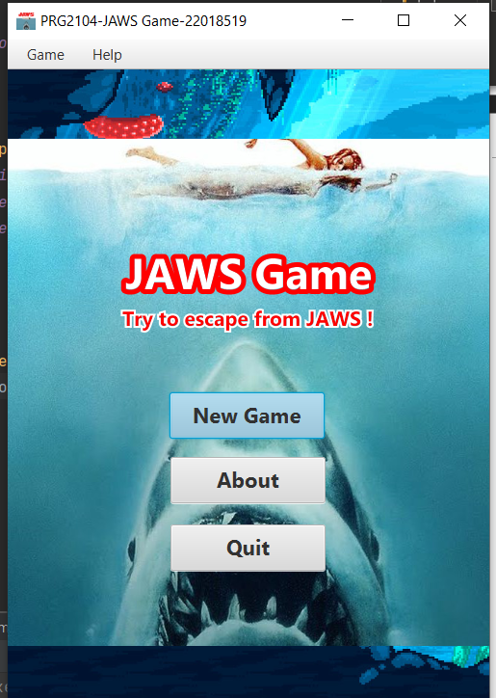**3.1 Main Menu**

Users are presented with a main menu upon launching the application. The main menu offers options to start a new game, learn about the game, and exit the application.

**3.2 About Information**

Users can access information about the game's rules and objectives. An information dialog provides details on how to play the game and what the user's goal is.

**3.3 Game Initialization**

When a new game is started, the game field is initialized with a random configuration of shark and vacant tiles. The mine count and time counter are reset to their initial values.

**3.4 Tile Click Interaction**

Users can click on tiles to reveal their content. Shark tiles display a shark image, vacant tiles display the number of surrounding shark tiles, and number tiles show their own number.

**3.5 Shark Counter**

Users are provided with a mine counter that displays the number of remaining shark tiles. The counter decreases as vacant tiles are revealed.

**3.6 Time Counter**

A time counter keeps track of the duration of the ongoing game in seconds. The counter starts when the game begins and stops when the game ends.

**3.7 Winning Condition**

The game ends in a win if all vacant tiles are successfully revealed without revealing any shark tile. An alert message is displayed congratulating the user on their victory.

**3.8 Losing Condition**

The game ends in a loss if a shark tile is revealed by the user. An alert message notifies the user of their unfortunate fate.

**3.9 Revealing All Tiles on Loss**

In case of a loss, all tiles are automatically revealed to display their content. Shark tiles are shown with a shark image.

**3.10 Restarting the Game**

After a game ends (win or loss), users can choose to start a new game by clicking the restart button at the bottom of the game board. The game field is reinitialized, and the counters are reset.

**3.11 Exiting the Application**

**

Users can choose to exit the application from the main menu. Graphical User Interface (GUI): The game features a user-friendly GUI built using the ScalaFX library. Buttons, labels, and images are utilized to create an interactive and visually appealing interface.

**4.0 Object-Oriented Concepts Applied**

**4.1 Inheritance and Polymorphism**

The project incorporates inheritance and polymorphism through class hierarchies and overriding methods. The Tile class serves as a base class with subclasses SharkTile, VacantTile, and NumberOfTile. Polymorphism is demonstrated by using a common method (openTile) across different tile types.

**4.2 Abstract Class**

The abstract class Counter is utilized to represent the counters for sharks and time. This abstraction simplifies counter management and allows for easy extension to other counter types if needed.

**4.3 Generic Programming**

Generic programming is employed in the Counter class to create a generic counter structure that can be used for various counter types, such as shark and time counters.

**5.0 Personal Reflection**

In developing this project, I gained a deeper understanding of how to apply object-oriented programming concepts to create well-structured and modular code. The design process highlighted the importance of class hierarchy and code reuse, leading to more efficient and maintainable code. I faced challenges in managing the graphical interface and event-driven programming, but through diligent research and practice, I was able to achieve elegant and functional GUI components.

**5.1 Challenges and Solutions**

**5.1.1 Graphical Interface**

Designing and implementing the GUI was challenging due to the need for proper layout and responsiveness. I overcame this by studying the ScalaFX documentation, experimenting with layout classes, and refining the interface iteratively.

**5.1.2 Tile Click Handling**

Implementing tile click functionality while maintaining the integrity of the game's logic was complex. To address this, I used a combination of controller methods, model logic, and event handlers to ensure proper tile interaction.

**5.2 Strengths and Weaknesses**

**5.2.1 Strengths**

-Effective use of object-oriented principles, resulting in a well-structured and extensible codebase.

-Mastery in event-driven programming and utilization of ScalaFX's GUI components.

Demonstrated understanding of inheritance, polymorphism, abstract classes, and generic programming.

**5.2.2 Weaknesses**

-In some cases, the code could benefit from further optimization and refactoring.

-Documentation could be more comprehensive and should include code comments for better understanding.

**6.0 Conclusion**

The completion of the JAWS game project has been a valuable learning experience. By integrating object-oriented programming concepts and applying them in a practical context, I have deepened my understanding of software design and coding practices. The challenges encountered during the development process served as opportunities for growth and learning, leading to a more robust and functional application.

**References**

﻿ScalaFX simpler way to use javafx from scala. ScalaFX Simpler way to use JavaFX from Scala. (n.d.). <https://www.scalafx.org/>

Steven Spielberg, John Williams & John Williams. (1975) JAWS. USA.

Becerra, David J. 2015. Algorithmic Approaches to Playing Minesweeper. Bachelor's thesis, Harvard College. Available at: <http://nrs.harvard.edu/urn-3:HUL.InstRepos:14398552>

Google [Google](https://www.google.co.in/)